Install JoGL v2.0 on Windows 7.0 Using Console

Wanwan Li

1st: Download jogamp-all-platforms from website
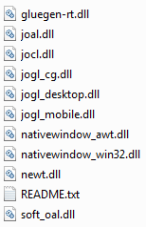

2nd: Copy these jar files into: Java\jogl.2.0\jar\
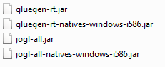
3rd: Copy these dll files into: Java\jogl.2.0\lib\
4th :Update Environment Variables Settings:
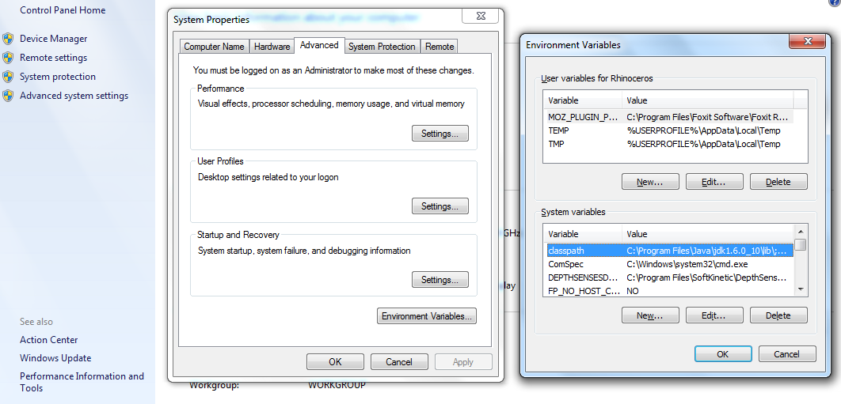
5th : Add the jar dir “ C:\Program Files\Java\jogl.2.0\jar\*; ” into the classpath.
^{6th} : Add the lib dir “ C:\Program Files\Java\jogl.2.0\lib\windows-i586\; ” into the path.
7th : Using cmd to start running a console window, use javac *.class to compile all the code,
8th : Using java <class_name> to run a sample. Like this:
